Human Pedigrees

Hints for analyzing pedigrees:

1) If the individual is homozygous recessive, then both parents MUST have at least
one recessive allele (parents are heterozygous or homozygous recessive).

2) If an individual shows the dominant trait, then at least one of the parents MUST have the
dominant phenotype. This one will be pretty obvious when you look at the pedigree.

3) If both parents are homozygous recessive, then ALL offspring will be homozygous recessive.

For Questions 1-9, use the pedigree chart shown below. Some of the labels may be used more than once.
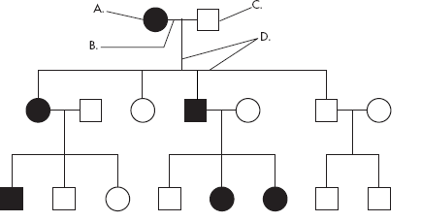

________ 1. A male
2. A female
________ 3. A marriage

4. A person who expresses the trait
5. A person who does not express the trait
6. A connection between parents and offspring

________ 7. How many generations are shown on this chart?

Assuming the chart above is tracing the dominant trait of "White Forelock (F)" through the family. F is a tuft of white hair on the forehead.
________8. What is the most likely genotype of individual “A”? (FF, Ff or ff?)
________9. What is the most likely genotype of individual “C”? (FF, Ff or ff?)

Trait: Falconi anemia
Forms of the trait:
- The dominant form is normal bone marrow function - in other words, no anemia.
- The recessive form is Falconi anemia. Individuals affected show slow growth, heart defects,
possible bone marrow failure and a high rate of leukemia.

A typical pedigree for a family that carries Falconi anemia. Note that carriers are not indicated with half-colored shapes in this chart.

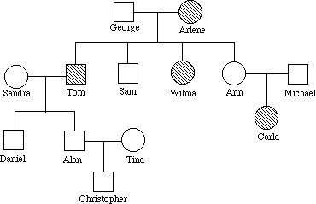

Analysis Questions.

To answer questions #1-5, use the letter "f" to indicate the recessive Falconi anemia allele, and the letter "F" for the normal allele.

1. What is the genotype of I.2?

2. What is genotype of I.1?

3. What are genotypes of II.5 and II.6? and

4. The genotype of II.1 is either or .

5. List three people from the chart (other than George) who are most likely carriers of Falconi anemia.

Human Pedigrees

Hints for analyzing pedigrees:

1) If the individual is homozygous recessive, then both parents MUST have at least
one recessive allele (parents are heterozygous or homozygous recessive).

2) If an individual shows the dominant trait, then at least one of the parents MUST have the
dominant phenotype. This one will be pretty obvious when you look at the pedigree.

3) If both parents are homozygous recessive, then ALL offspring will be homozygous recessive.

For Questions 1-9, use the pedigree chart shown below. Some of the labels may be used more than once.

________ 1. A male
2. A female
________ 3. A marriage

4. A person who expresses the trait
5. A person who does not express the trait
6. A connection between parents and offspring

________ 7. How many generations are shown on this chart?

Assuming the chart above is tracing the dominant trait of "White Forelock (F)" through the family. F is a tuft of white hair on the forehead.
________8. What is the most likely genotype of individual “A”? (FF, Ff or ff?)
________9. What is the most likely genotype of individual “C”? (FF, Ff or ff?)

Trait: Falconi anemia
Forms of the trait:
- The dominant form is normal bone marrow function - in other words, no anemia.
- The recessive form is Falconi anemia. Individuals affected show slow growth, heart defects,
possible bone marrow failure and a high rate of leukemia.

A typical pedigree for a family that carries Falconi anemia. Note that carriers are not indicated with half-colored shapes in this chart.

Analysis Questions.

To answer questions #1-5, use the letter "f" to indicate the recessive Falconi anemia allele, and the letter "F" for the normal allele.

1. What is the genotype of I.2?

2. What is genotype of I.1?

3. What are genotypes of II.5 and II.6? and

4. The genotype of II.1 is either or .

5. List three people from the chart (other than George) who are most likely carriers of Falconi anemia.

